Given the root of a binary tree and two integers p and q, return *the****distance****between the nodes of value*p*and value*q*in the tree*.

The **distance** between two nodes is the number of edges on the path from one to the other.

**Example 1:**

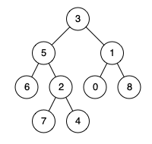

**Input:** root = [3,5,1,6,2,0,8,null,null,7,4], p = 5, q = 0

**Output:** 3

**Explanation:** There are 3 edges between 5 and 0: 5-3-1-0.

**Example 2:**



**Input:** root = [3,5,1,6,2,0,8,null,null,7,4], p = 5, q = 7

**Output:** 2

**Explanation:** There are 2 edges between 5 and 7: 5-2-7.

**Example 3:**



**Input:** root = [3,5,1,6,2,0,8,null,null,7,4], p = 5, q = 5

**Output:** 0

**Explanation:** The distance between a node and itself is 0.

**Constraints:**

* The number of nodes in the tree is in the range [1, 104].
* 0 <= Node.val <= 109
* All Node.val are **unique**.
* p and q are values in the tree.